Newspaper contact details, template and folders

Email addresses

The Age: letters@theage.com.au
Sunday Age: sunday@theage.com.au
The Australian: letters@theaustralian.com.au
The Australian Weekend Magazine: magazinefeedback@theaustralian.com.au
The Australian Financial Review: edletters@afr.com.au

The Herald Sun: hsletters@heraldsun.com.au
The Sydney Morning Herald: letters@smh.com.au
The West Australian: letters@wanews.com.au
Canberra Times: letters.editor@canberratimes.com.au
The Saturday Paper: letters@thesaturdaypaper.com.au

Other newspapers (online forms)
For other papers, use your browser to search for “send letter to editor <newspaper name>”
For example, “send letter to editor Bendigo Advertiser” returns https://www.bendigoadvertiser.com.au/comment/send-a-letter-to-the-editor/
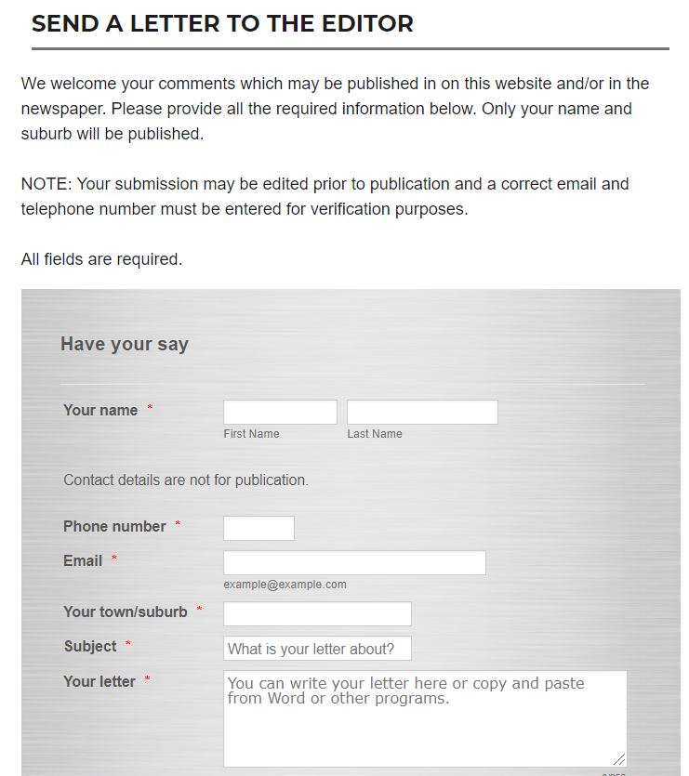

Template
To save time and also ensure you don’t forget to include details, use this template.
The Editor
<newspaper name>
<date>
<catchy title of letter – optional>
<text of your letter here>
<your name, suburb, <state if writing interstate>>
<your FULL address>
<your phone number>

Letter writing folders
To save reinventing the wheel, use a chronological naming system and file your sent letters into a searchable folder. This allows letter wording to be re-used for new letters.
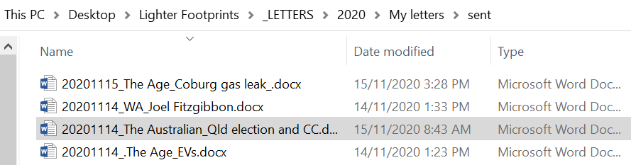
For example, a search for “biodiversity” yielded
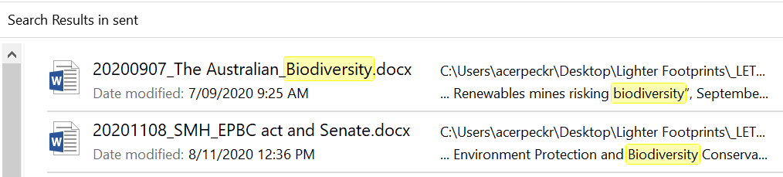
File reports and resources for your writing into folders

